

Australian Education Academy Pty Ltd
2006

MATHEMATICAL METHODS
UNITS 3 & 4

WRITTEN EXAMINATION 2

Reading time: 15 minutes
Writing time: 2 hours

Student’s name: ______________________________________

Directions to students
This examination consists of four analysis questions and 22 multiple choice questions.
Answer all questions.
All working and answers should be written in the spaces provided.
The marks allotted to each part of each question appear at the end of each part.
There are 77 marks available for this task.

These questions have been written and published to assist students in their preparations for the 2006 Mathematical Methods Examination 2. The questions and associated answers and solutions do not necessarily reflect the views of the Victoria Curriculum and Assessment Authority

© Australian Education Academy Pty Ltd 2006
This Trial Examination is licensed to the purchasing school or educational organisation with permission for copying within that school or educational organization. No part of this publication may be reproduced, transmitted or distributed, in any form or by any means, outside purchasing schools or educational organizations or by individual purchases without permission.

Published by Australian Education Academy Pty Ltd
ABN: 18 104 474 893
292 Mount Alexander Road, Ascot Vale, Vic. 3032
Ph: (03) 9370 0666 Fax: (03) 9375 7277
Email: wendy@aust-education.com.au

SECTION A - MULTIPLE CHOICE QUESTIONS

Question 1

Rule is a given graph of a function ,

x=1
x=2

(i) 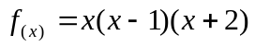
(ii) 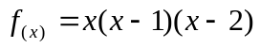
(iii) 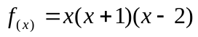
(iv) 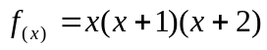
(v) 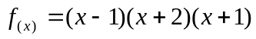

Question 2
Solution of the equation 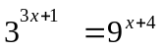 is

(i) 8 (ii) 6 (iii) 5 (iv) 7 (v) 3

Question 3

If log₂X + log_{x}2 = 2 then X is

(i) 2 (ii) 4 (iii) (iv)  (v) 1

Question 4

Inverse function of 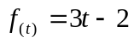

(i) 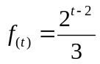 (ii) 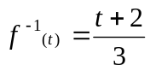 (iii) 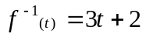 (iv) 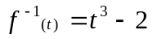

(v) 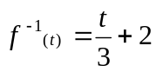

Question 5

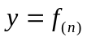is a function. It’s graph is shown below. What is it’s mirror image on Y = X

Y
y =f(x)

X Y

(i) X

(ii) Y (iii) Y (iv) Y (v) Y

X X X X

Question 6

If 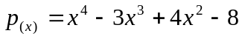 exactly divided by

(i) 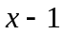 ii) 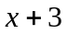 (iii) 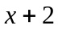 (iv) 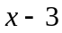 (v) 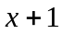

Question 7

Possible factors of the function 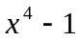 are ,

(i) 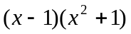
(ii) 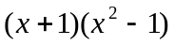
(iii) 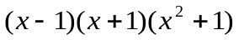
(iv) 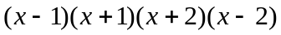

Question 8

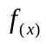 is a function, it’s graph is given below.
Y

X=1 X
(i) f(x) = |x+1| (ii) f(x) = x² + 1 (iii) f(x) = x² - 1

(iv) f(x) = |x-1| (v) f(x) = x-1

Question 9

The equation of the given graph is,
y

x=3
x

Y= -2

(i)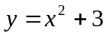
(ii) 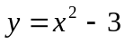
(iii) 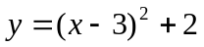
(iv) 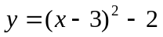
(v) 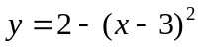

Question 10

The graph of y as a function of x is given,

y=f(x)

x = a
x

 | dy/ dx
(i)  (ii)  (iii)  (iv)  (v) | 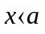  (+) ve  (-) ve  (+) ve  (-) ve  (-) ve | 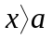  (+) ve  (-) ve  (-) ve  (+)ve  (+) ve | equal to zero  not equal to zero  not equal to zero  equal to zero  not equal to zero

Question 11

If 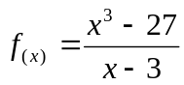 f(x) can’t be defined when,

(i) 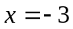
(ii) 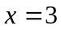
(iii) 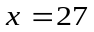
(iv) 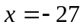
(v) 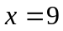

Question 12

If 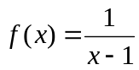 f¹(x) is,

(i) 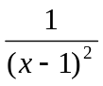 i) 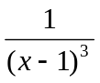
(iii) 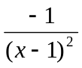 v) 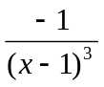 (v) 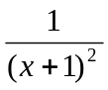

Question 13

Y = Cos X then dy is,
X dx

(i) 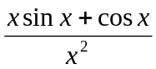 (ii) 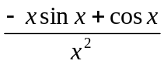 (iii) 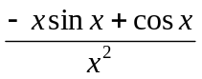

(iv) 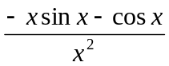 (v) 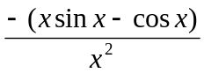

Question 14

The number of linear asymptotes of the curve 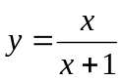 is,

- 1
- 2
- 0
- 4
- ∞

Question 15

If 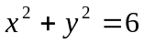, then  is

- 2y + 2x
- 6 – x²
- -y/x
- -x/y
- -y²/x²

Question 16

The graph of the function f(θ) = Cos(2 θ – π/4) has a period

(i) 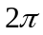
(ii)
(iii) 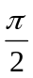
(iv) 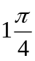
(v) 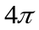

Question 17

Solutions of the equation Cosθ = 1/2 in the range 0 ≤ θ ≤ 2π is,
(i) 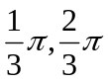
(ii) 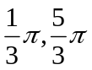
(iii) 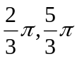
iv) 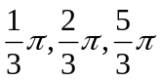
v) 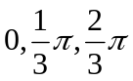

Question 18
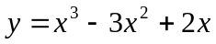 curve cuts x-axis at,

(i)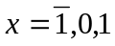 (ii) 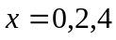 (iii) 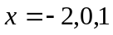 (iv) 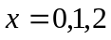 (v) 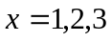

Question 19

∫(x² – 1/x² + Sin)dx is

(i) 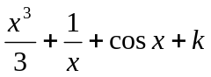
(ii) 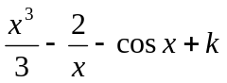
(iii) 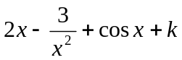
(iv) 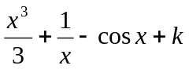
(v) 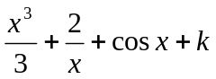

Question 20

The value of 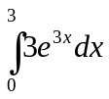 is ,

(i) 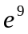 (ii) 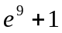 (iii) 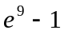 (iv) 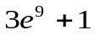 (v) 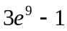

Question 21

The probability distribution for the random variable x is given by

X = x | 1 | 2 | 3 | 4 | 5 | 6
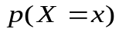 | 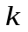 | 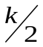 | 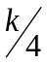 | 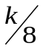 | 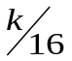 | 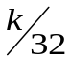

The value of the k is ,
(i) 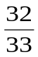 (ii) 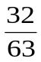 (iii) 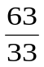 (iv) 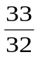 (v) 1

Question 22

Four balls are taken at random and of a box connoting six yellow and four blue balls .
What is the probability that at leased two yellow balls are removed ?

(i) 0.119 (ii) 0.86 (iii) 0.5 (iv) 0.6 (v) 0.77

SECTION B - Written Examination 2: Analysis Task

Question 1
Consider the function 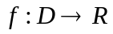, for which the rule is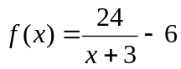 where D is the maximal domain for f.

a. Find D

[1 mark]

b. Describe a set of transformations which when applied to the graph of 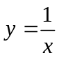, produce the graph of 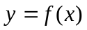.

[3 marks]

c. Find the coordinates of the points where the graph of f cuts the axes.

[1 mark]

d. Let 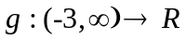, 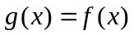

(i). State the domain and range of g

[1 mark]
(ii). Find the rule for 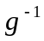, the inverse of .

[2 marks]

(iii). Find the coordinates of the points where the graph of g⁻¹ cuts the axes.

[1 mark]

(iv). Write down the domain of .

[1 mark]

(v). Find the values of x for which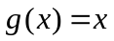 and hence the values of x for which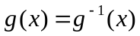.

[3 marks]

(vi). Sketch the graphs of 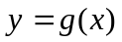and 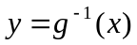 on the one set of axes.
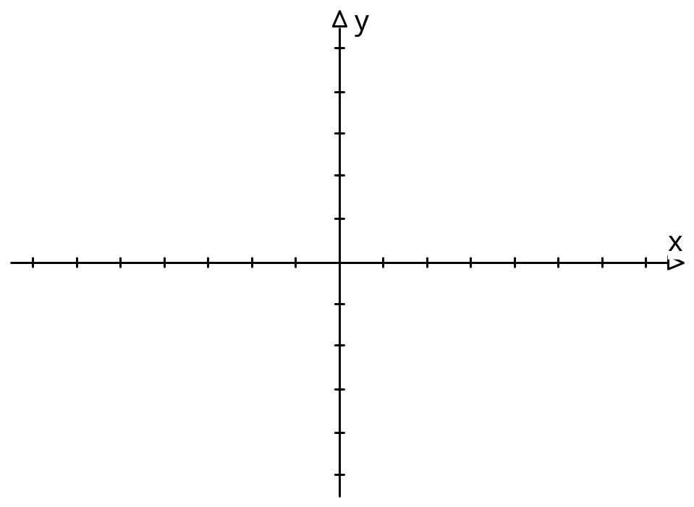
[2 marks]
[Total 15 marks]
Question 2

The population of rabbits on a particular island t weeks after a virus is introduced is modeled by 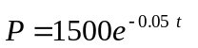, where P is the number of rabbits.

a. Find the initial size of the population

[1 mark]

b. Find the time taken for the population to halve (to the nearest week)

[1 mark]

c. Obtain an expression to calculate the rate of decrease of the population at time t.

[1 mark]

d. Find the rate of decrease of the population.

(i). after 2 weeks

[1 mark]
(ii). after 10 weeks.

[1 mark]
After 16 weeks the virus has become ineffective and the population of rabbits starts to increase again according to the model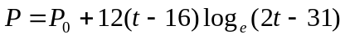 where t is the number of weeks since the virus was first introduced.

e. State the domain of P

[1 mark]
f. Determine the value of 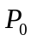

[1 mark]

g. Find the size of the population after 32 weeks.

[1 mark]

h. Derive an expression to calculate the rate of increase of the population at time t.

[2 marks]

i. Find the rate of change of the population
(i). after 20 weeks

[2 marks]
(ii). and 32 weeks.

[2 marks]

j. Write down an equation to find how many weeks the population takes to get back to its original number.

[1 mark] [Total 15 marks]

Question 3

A closed capsule is to be constructed as shown in the diagram. It consists of a circular cylinder of height h cm and radius r cm, with hemispherical caps of radius r cm on each end.

r
h

a.
(i). Show that the volume, V 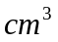, the capsule is given by 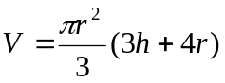.

[2 marks]
(ii). Show that the surface area of the capsule ,S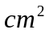, is given by 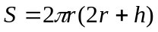.

[2 marks]

b.
(i). If 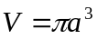, where a is a positive constant find h in terms of a and r.

[1 mark]
(ii) The values which r can take lie in an interval. Find the end points of this interval.

[2 marks]
(iii). Find S in terms of a and r.

[1 mark]

c.
(i). Find an expression for 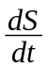 and hence find the coordinates of the turning points.

[2 marks]

(ii) Determine the nature of the turning point and the corresponding value of S

[2 marks]

(iii). By using addition of ordinates or otherwise sketch the graph of S against r for a suitable domain.
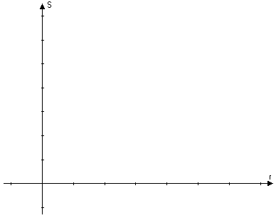 [3 marks]
[Total 15 marks]

Question 4

A multiple choice examination consists of 25 questions, for each of which the candidate is required to tick as correct one of 5 possible answers. Exactly one possible answer to each question is correct. A correct answer gets 1 mark and a wrong answer gets 0 marks. Consider a candidate who has complete ignorance about every question and therefore ticks at random. The random variable X denotes the number of correct answers.

a. What is the probability that he gets a particular answer correct?

[1 mark]
b. What is the distribution of X?

[1 mark]
c. Write down the probability distribution of X?

[1 marks]

d. Calculate the mean, the variance and the standard deviation of X.

[3 marks]
e. Calculate the probabilities that he gets zero marks for the paper.

[1 mark]

f. The examiners wish to ensure that not more than 1% of completely ignorant candidates pass the examination. Use Normal approximation to obtain the mark that meets this requirement.

[3 marks]
[Total 10 marks]

